|  |  |  |  |
| --- | --- | --- | --- |
|  | **COLLEGE OF COMPUTING AND INFORMATION SCIENCES** | | |
| **Final Examination Assessment Spring 2021 Semester** | | |
| **Class Id** | 106366 | **Course Title** | DSA Theory |
| **Program** | BSCS | **Campus / Shift** | Main Campus / Morning |
| **Date** |  | **Total Marks** | 40 |
| **Duration** | 03 hours | **Faculty Name** | Mehak Riaz Khan/ Muhammad Minhal Raza |
| **Student Id** |  | **Student Name** |  |

**Instructions:**

* Fill out your Student ID and Student Name in above header.
* Do not remove or change any part of question paper.
* Write down your answers with title “Answer for Question# 00”.
* Handwritten text or image should be on A4 size page with clear visibility of contents.
* In case of CHEATING, COPIED material or any unfair means would result in negative marking or ZERO.
* **Caution:** Duration to perform Final Examination Assessment is **03 hours only**. **Therefore, if you failed to upload answer sheet on LMS (in PDF format) within 3 hours limit, you would be considered as ABSENT/FAILED.**

# Question-1 (10-Marks)

**Friend’s Party Circle:**

There are a few friends living in the same area. They have a party every weekend and the place of party change each week. It is always a difficult task to select a place which is nearest for everyone. They all decided to take advantage of Computer Science to solve this problem.

Names of friends are Ahmed, Rehman, Careem, Basit, Dawood, Ghani, and Farid. Ahmed lives at 5 minutes’ walk from rehman and at 10 minutes’ walk from Careem. Careem lives at 3 minutes’ walk from Dawood. Rehman lives at 4 minutes’ walk from Basit and 2 minutes’ walk from Dawood. Dawood lives at two minutes’ walk from Farid. Ghani lives at 2 minutes’ walk from Basit.

1. If we represent a graph **G = V (V, E)** in which set of vertices are home of each Friend and an edge represents a path between two homes. Provide the adjacency matrix of directed graph of the graph G.
2. In above directed graph G. You are required to devise an **algorithm** to find all possible paths.

# Question-2 (10-Marks)

1. Suppose **T** is the binary Tree. Provide its sequential list memory representation form of the following Tree and don't show the empty cell of an array.

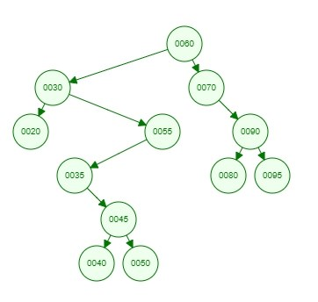

1. Suppose the following list of letters is inserted in an order into an empty list binary search tree

*J,R,D,G,T,E,M,H,P,A,F,Q*

Using the insertion algorithm of binary search tree:

1. Construct the tree.
2. Traverse it, in in-order form.
3. Apply searching Algorithm to find the location of node ‘F’. Mention the Number of Comparison that are made until you find location ‘F’.

# Question-3 (10-Marks)

Write an algorithm for a method named **Delete_Prime_Numbers_From_Stack** which takes the stack of integers values as input and removes all the prime values that a stack contains. No need to write whole/extra code of push, pop functions. You have to write only the above method procedure.

**Note:** Make sure that there is no change of order in the remaining stack values after removing the prime values from it.

If we have a Stack S of integer values like

|  |
| --- |
| 23 |
| 18 |
| 8 |
| 3 |
| 21 |
| 2 |

After calling the above mentioned method the remaining values which are in the stack like

|  |
| --- |
| 18 |
| 8 |
| 21 |

# Question-4 (10-Marks)

Using Queues Operation Enqueue,Dequeue, Write a algorithm of method names **Contain_Equal** that takes the strrings “aaabbb” in queue form as input and returns that the strings contain equal numbers of a’s and b’s

|  |  |  |  |  |  |
| --- | --- | --- | --- | --- | --- |
| A | A | A | B | B | B |

Ouput Must be Like: Both A’s and B’s are Equal In Quantity Which Is 3.

**GOOD LUCK ☺**